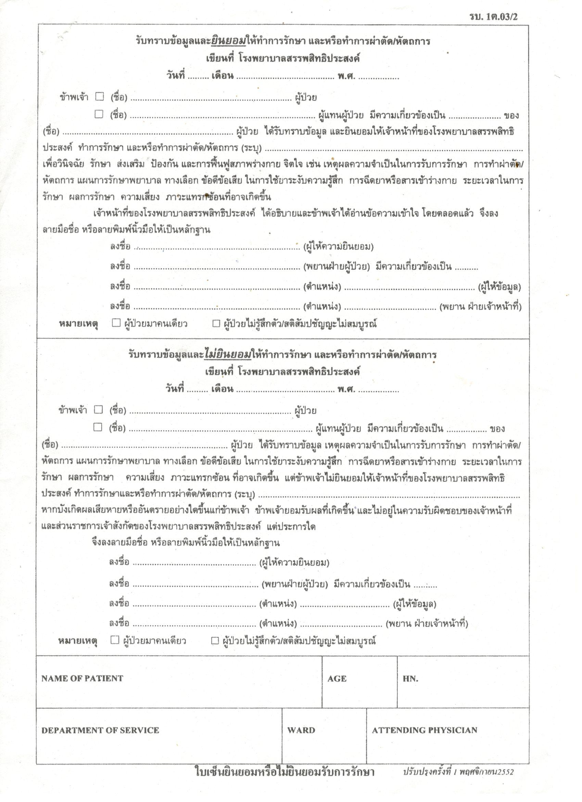

Personal Information, Medical Services and/or Surgery Consent Form
Written at Sunpasitthiprasong Hospital
Date_______ Month __________ Year_______

“I” [_] (Patient Name)_______________________________________________________________
[_] (Patient Representative Name)___________________________________ Relationship to thePatient________
Sunpasitthiprasong Hospital personnel to perform all needed medical services and/or any surgical procedures. (Specifically): ____________________________ in order to discover, care for, promote, prevent and all needed procedures to facilitate patient recovery including mental health, all reasonable treatments, surgical procedures, and all nursing care plans in order to choose the best procedures for the administration of anesthesia. This includes all medicinal injections while being cared for regardless of outcome, risks or complications that may arise.
Sunpasitthiprasong Hospital personnel have explained and I have read all this information and understand it in full leading to my signing or rendering my fingerprint on this form as proof thereof.

Signed:_____________________________________ (Consenting Party)
Signed:______________________________(Patient Witness) Relationship: ______________________
Signed:_____________________________ (Title of Informing Official) _________________________
Signed:_____________________________ (Title of Witness for Informing Official) _______________
Note: [_] Patient came into hospital alone. [_] Patient was unconscious or not lucid upon arrival.

Personal Information, Medical Services and/or Surgery Non-Consent Form
Written at Sunpasitthiprasong Hospital
Date_______ Month __________ Year_______
“I” [_] (Patient Name)_______________________________________________________________
[_] (Patient Representative Name)___________________________________ Relationship to thePatient_________________________
Patient Name:___________________________________________ understands all information, reasons and needs concerning treatments, surgical procedures, nursing care plans in order to discover the best care for and in order to choose the best procedures for the administration of anesthesia. This includes all medicinal injections while being cared for regardless of outcome, risks or complications that may arise. But, I DO NOT CONSENT to allowing Sunpasitthiprasong Hospital personnel to perform any care, surgical procedures. (Specifically):_________________________________________________________.
And if any adverse or dangerous consequences arise regardless of type in my life, I accept those circumstances and understand that there is no liability or responsibility on the behalf of personnel or any other government officials of Sunpasitthiprasong Hospital.
Signing my name or rendering my fingerprint on this form as proof thereof.
Signed:_____________________________________ (Non-Consenting Party)
Signed:____________________________(Patient Witness) Relationship: ____________________
Signed:_________________________(Title of Informing Official) _________________________
Signed:_________________________(Title of Witness for Informing Official) _______________
Note: [_] Patient came into hospital alone. [_] Patient was unconscious or not lucid upon arrival.

NAME OF PATIENT……………………………………………. AGE:.................................. HN:………………..……

DEPARTMENT OF SERVICE: ……………… WARD: ………….. ATTENDING PHYSICIAN:…………………………..

CONSENT OR I DO NOT CONSENT NOTE

